LAB Assignment 11.1
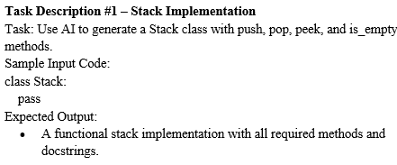

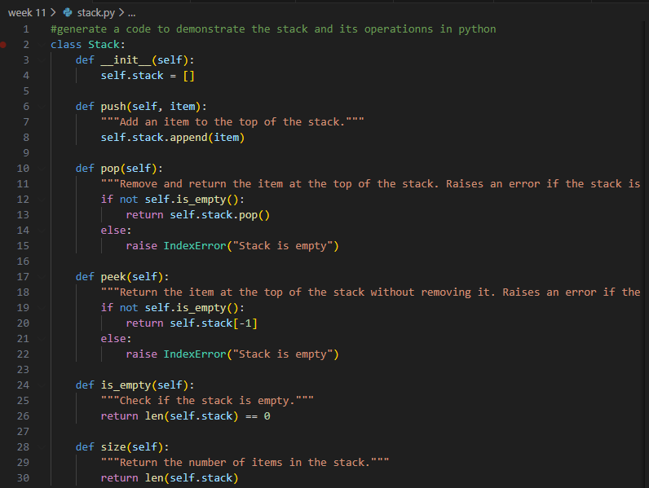
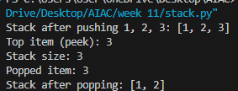
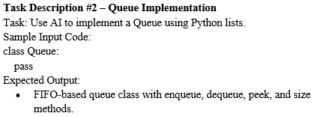

#Code :
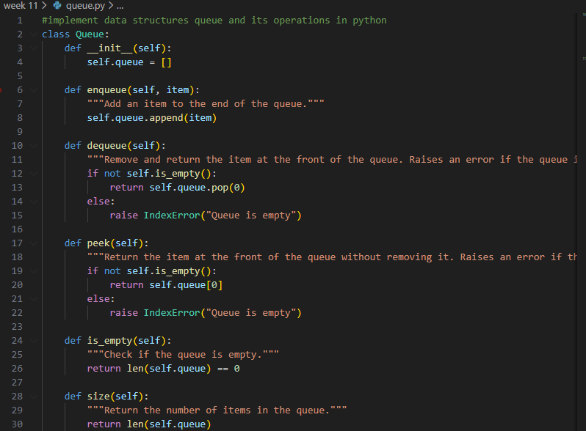

Output :
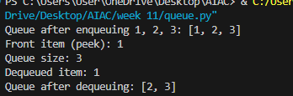

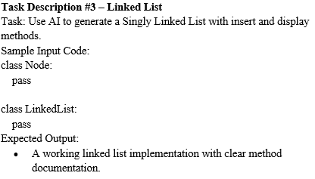
Code :
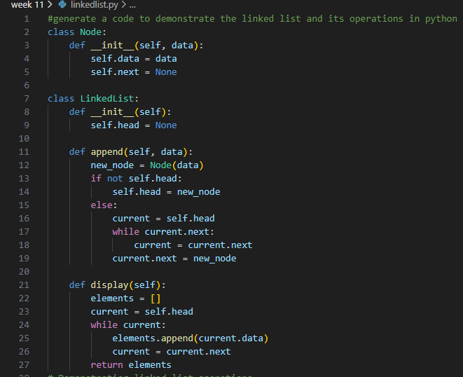
OUTPUT:
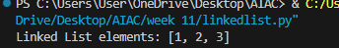
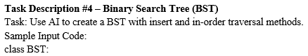
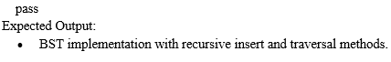
code:
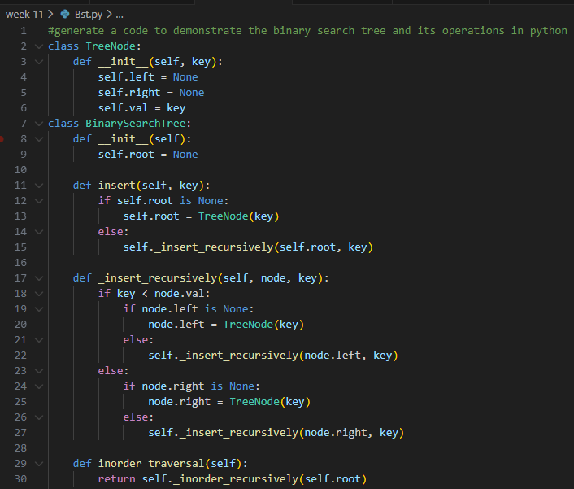

Output:
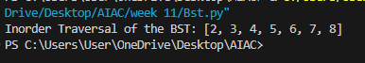

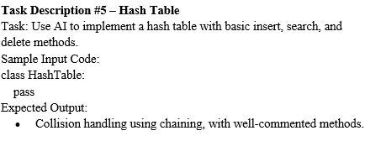

Code :

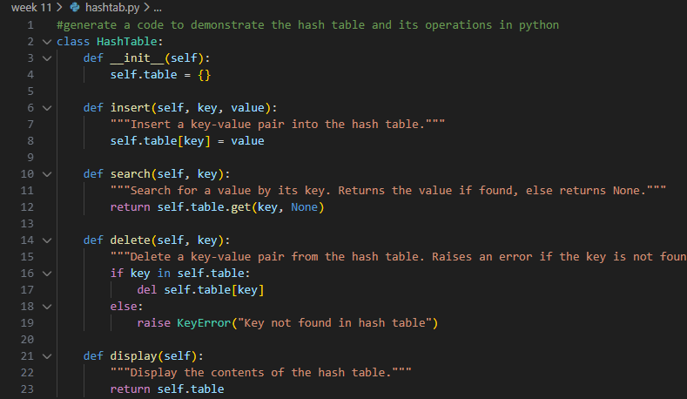

Output :

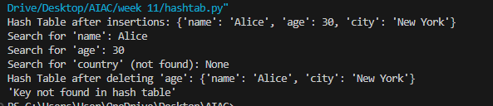

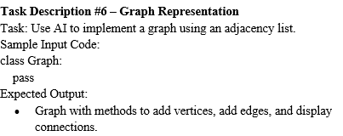
#Code :
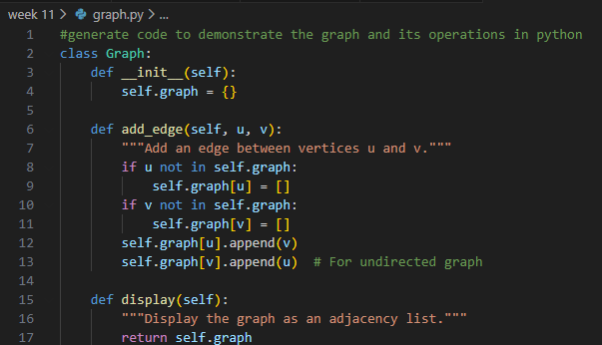
Output :
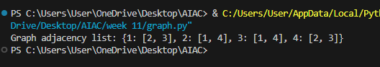

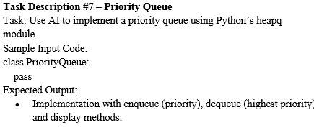
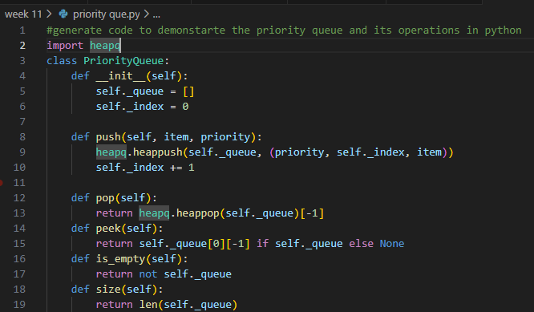

Output :

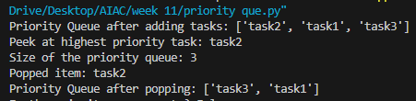

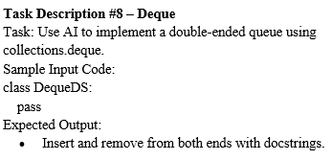

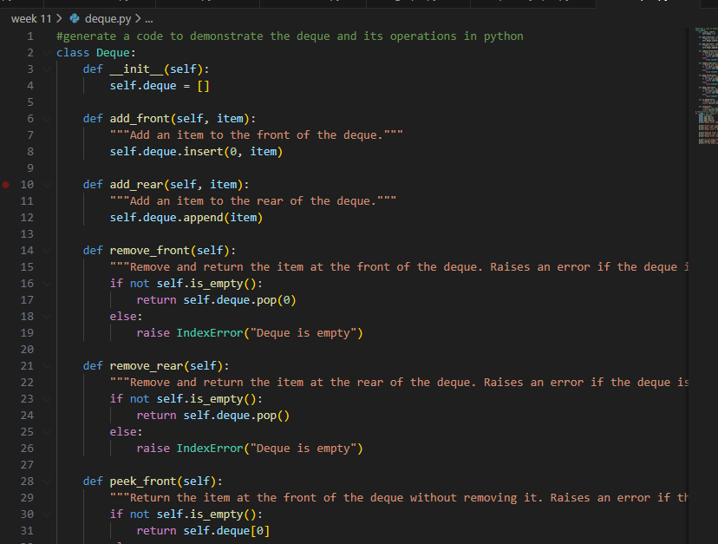
#Output :
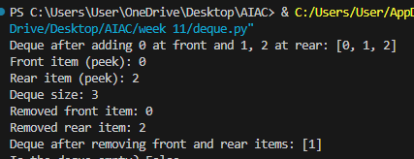


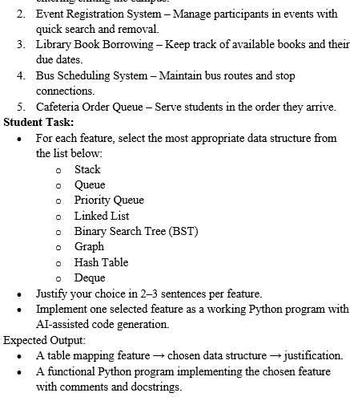

Feature | Data Structure | Justification
Student Attendance Tracking | Hash Table | Student attendance can be stored using student ID as a key. Hash tables allow very fast lookup and update of attendance records. This makes it efficient to track daily entry and exit of students.
Event Registration System | Binary Search Tree (BST) | Event participants can be stored in sorted order based on ID or name. BST allows efficient insertion, deletion, and searching operations. This helps manage participants quickly.
Library Book Borrowing | Priority Queue | Some books may have higher priority (e.g., reserved books or urgent academic needs). Priority queue allows books with higher priority to be issued first. This ensures important requests are handled earlier.
Bus Scheduling System | Graph | Bus stops and routes are connected like a network. Graph data structure represents connections between stops effectively. It helps in finding routes between different locations.
Cafeteria Order Queue | Queue | Students are served in the order they arrive at the cafeteria. Queue follows the FIFO (First In First Out) principle. This ensures fair and orderly service.
Student Attendance Tracking :
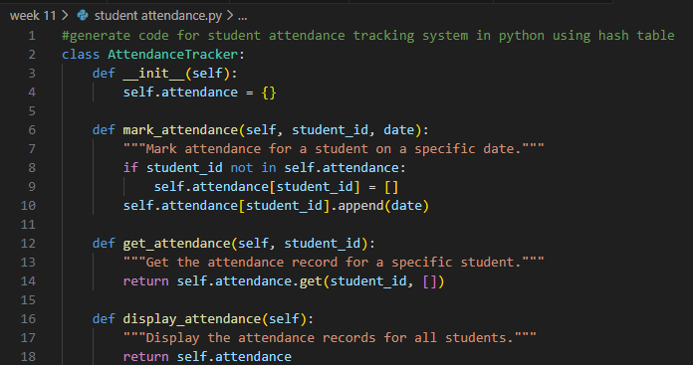

Output :

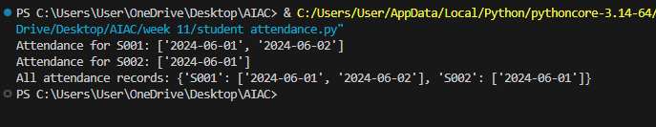

Library Book Borrowing
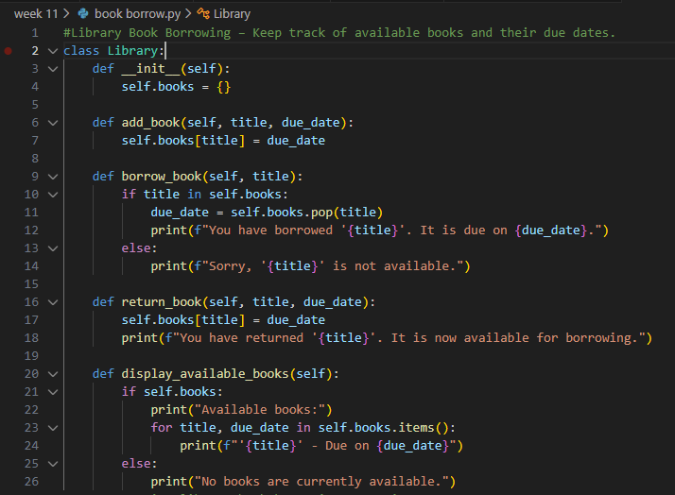
Output :
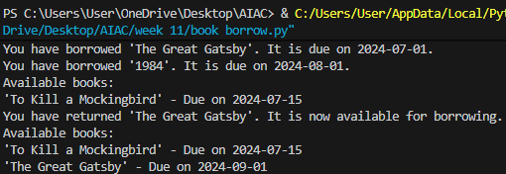
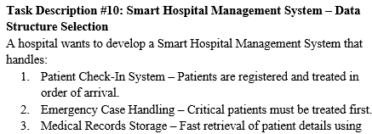
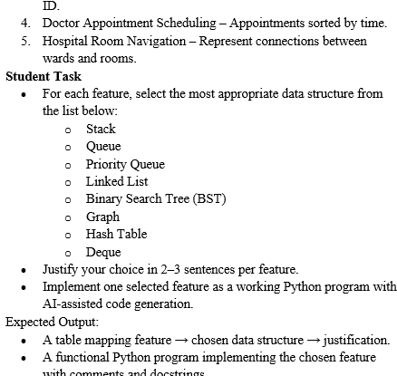

Feature | Data Structure | Justification
Patient Check-In System | Queue | Patients are treated in the order they arrive. Queue follows the FIFO (First In First Out) principle. This ensures fair processing of patients.
Emergency Case Handling | Priority Queue | Emergency patients must be treated before normal patients. Priority queue processes elements based on priority instead of arrival order. This ensures critical cases are handled first.
Medical Records Storage | Binary Search Tree (BST) | Patient records can be stored based on patient ID. BST allows efficient searching, insertion, and retrieval of records. This helps doctors quickly access patient information.
Doctor Appointment Scheduling | Linked List | Appointments can be added or removed dynamically throughout the day. Linked list allows easy insertion and deletion without shifting data. This makes schedule management flexible.
Hospital Room Navigation | Graph | Hospital rooms and wards are connected like a network. Graph data structure represents connections between rooms effectively. It helps in finding paths between different hospital areas.
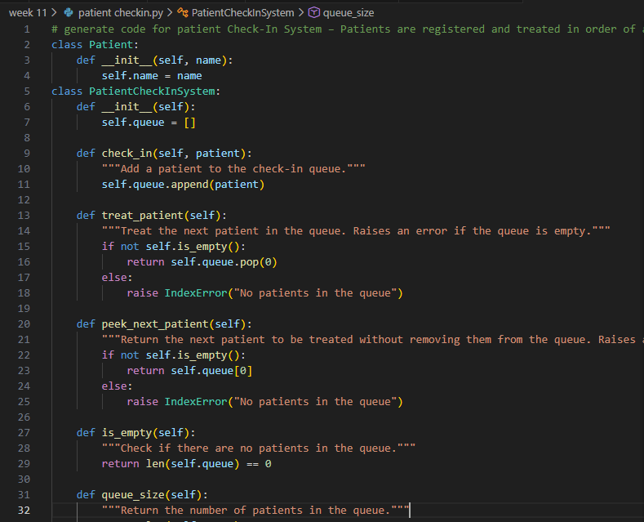

Output :

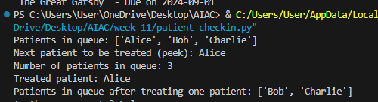

Doctor Appointment Scheduling
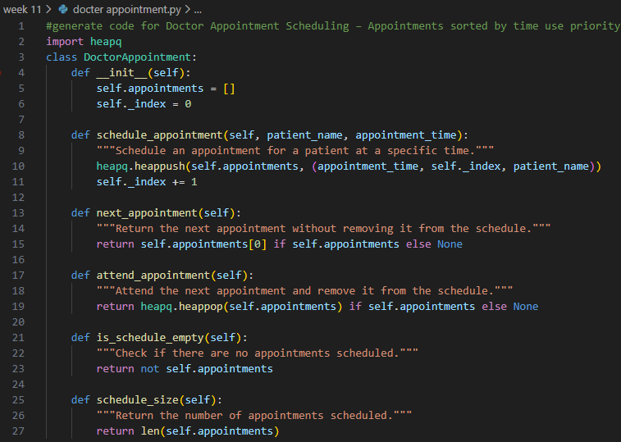

Output :
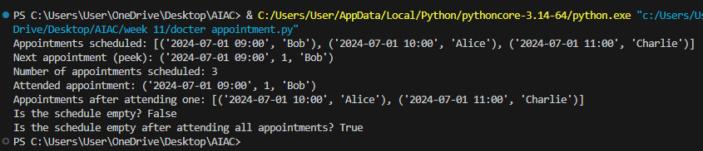

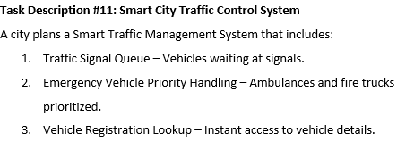

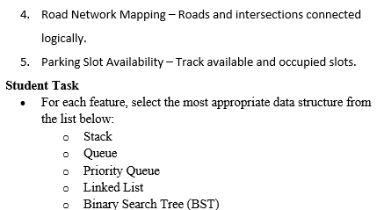
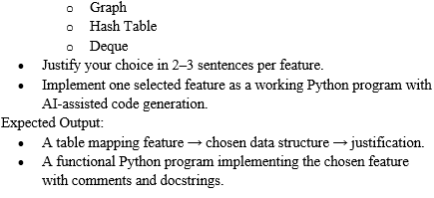

Feature | Data Structure | Justification
Traffic Signal Queue | Queue | Vehicles wait at traffic signals in the order they arrive. Queue follows the FIFO (First In First Out) principle. This ensures vehicles move in an organized order.
Emergency Vehicle Priority Handling | Priority Queue | Ambulances and fire trucks must move before normal vehicles. Priority queue allows vehicles with higher priority to be processed first. This helps emergency vehicles pass quickly.
Vehicle Registration Lookup | Hash Table | Vehicle details can be stored using the registration number as a key. Hash tables allow very fast search and retrieval of records. This makes vehicle lookup efficient.
Road Network Mapping | Graph | Roads connect intersections forming a network. Graph data structure represents connections between different roads and junctions. It helps in route planning and navigation.
Parking Slot Availability | Stack | In some parking systems, the last parked vehicle exits first. Stack follows the LIFO (Last In First Out) principle. This makes it suitable for parking management in limited spaces.
Traffic Signal Queue:
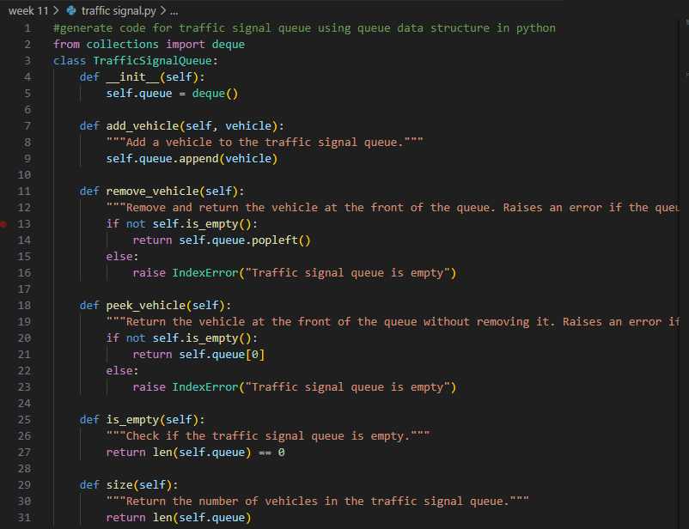

Output :

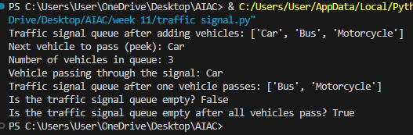
Parking Slot Availability :
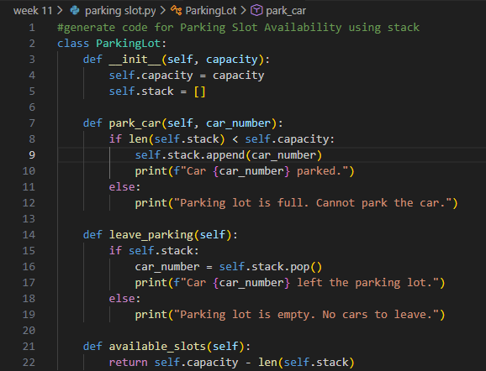
: 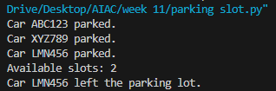
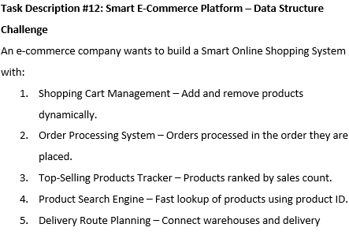
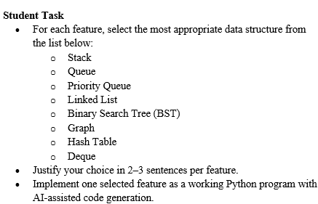

Feature | Data Structure | Justification
Shopping Cart Management | Linked List | Products can be added or removed dynamically from the shopping cart. Linked lists allow easy insertion and deletion without shifting elements. This makes cart management flexible.
Order Processing System | Queue | Orders must be processed in the order they are placed. Queue follows the FIFO (First In First Out) principle. This ensures fair order processing.
Top-Selling Products Tracker | Priority Queue | Products can be ranked based on the number of sales. Priority queue helps retrieve the highest selling products quickly. This is useful for displaying trending products.
Product Search Engine | Hash Table | Products can be searched using product ID. Hash tables provide very fast lookup operations. This allows quick retrieval of product details.
Delivery Route Planning | Graph | Warehouses and delivery locations are connected like a network. Graph data structure represents these connections effectively. It helps find the best delivery routes.

Shopping Cart Management :

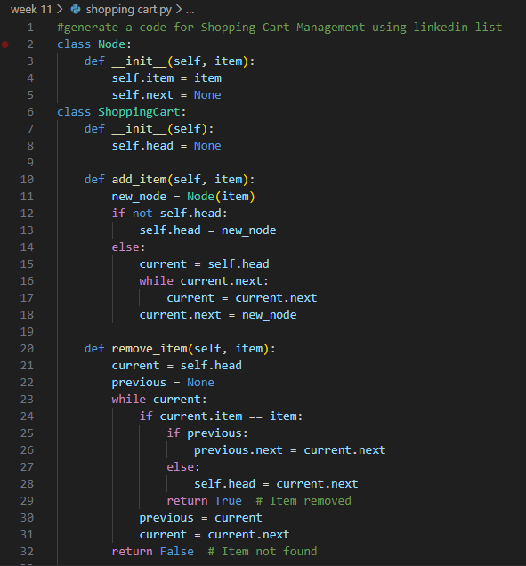

Output :

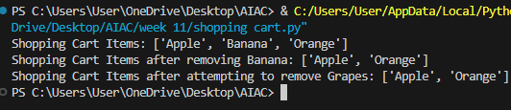
Top-Selling Products Tracker:
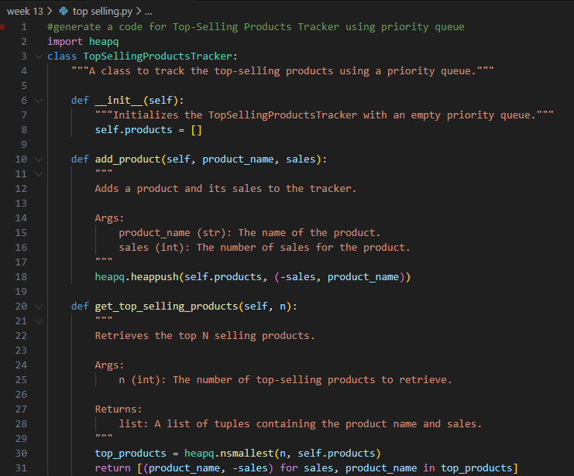
Output :
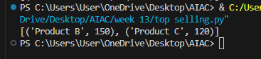
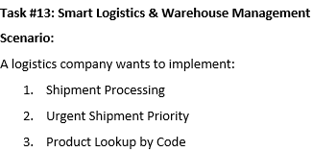

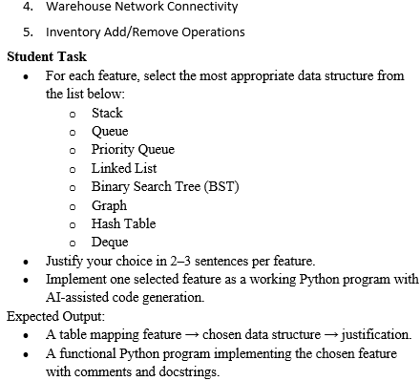

Feature | Data Structure | Justification
Shipment Processing | Queue | Shipments are processed in the order they arrive. Queue follows the FIFO (First In First Out) principle. This ensures fair and systematic shipment handling.
Urgent Shipment Priority | Priority Queue | Some shipments may be urgent and need faster delivery. Priority Queue processes shipments based on priority instead of arrival order. This ensures urgent shipments are delivered first.
Product Lookup by Code | Binary Search Tree (BST) | Products can be stored using their product code in a sorted structure. BST allows efficient searching, insertion, and deletion operations. This helps quickly retrieve product information.
Warehouse Network Connectivity | Graph | Warehouses and transport routes are connected like a network. Graph data structure represents connections between warehouses efficiently. It helps find routes between different warehouses.
Inventory Add/Remove Operations | Linked List | Inventory items are frequently added or removed. Linked List allows easy insertion and deletion without shifting elements. This makes inventory management flexible.

Warehouse Network Connectivity :
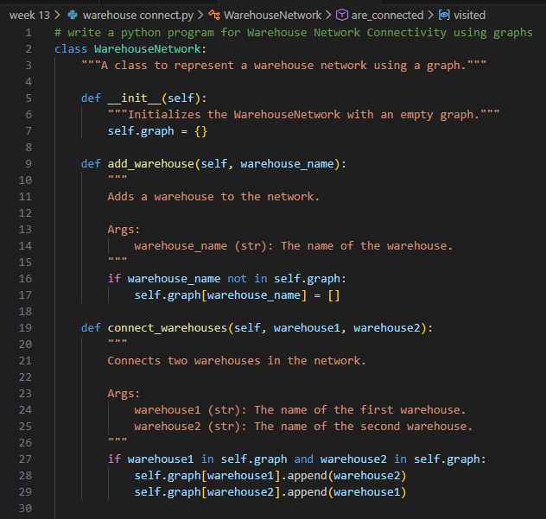
Output :
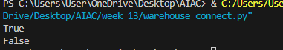

Inventory Add/Remove Operations:

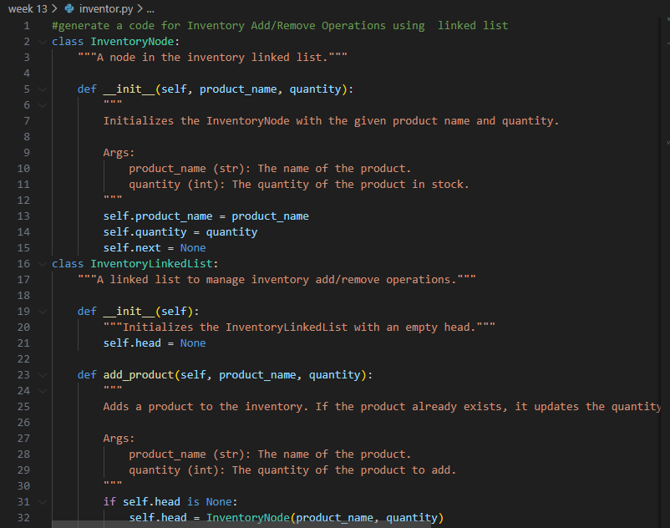

Output :

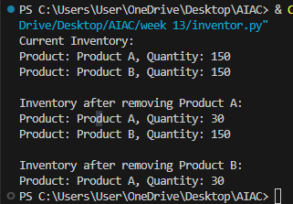

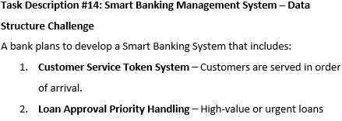
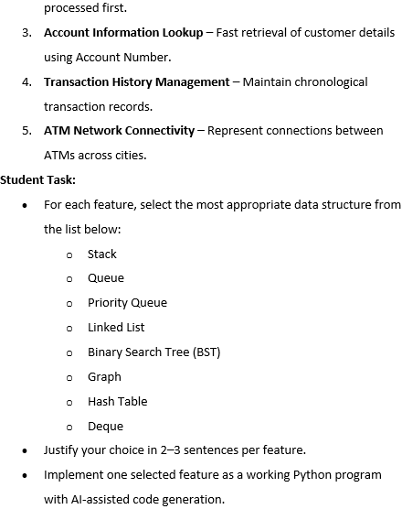

Feature | Data Structure | Justification
Customer Service Token System | Queue | Customers are served in the order they arrive at the bank. Queue follows the FIFO (First In First Out) principle. This ensures fair service and organized customer handling.
Loan Approval Priority Handling | Priority Queue | Some loan requests may be urgent or high value. Priority Queue processes requests based on priority instead of arrival order. This allows important loans to be processed first.
Account Information Lookup | Hash Table | Customer account details can be stored using account numbers as keys. Hash tables allow very fast searching and retrieval of information. This helps bank staff quickly access customer records.
Transaction History Management | Binary Search Tree (BST) | Transactions can be stored in sorted order using transaction ID or time. BST allows efficient insertion and searching operations. This helps manage and retrieve transaction records easily.
ATM Network Connectivity | Graph | ATMs in different cities are connected like a network. Graph data structure represents connections between ATMs efficiently. It helps in managing routes and connectivity between locations.

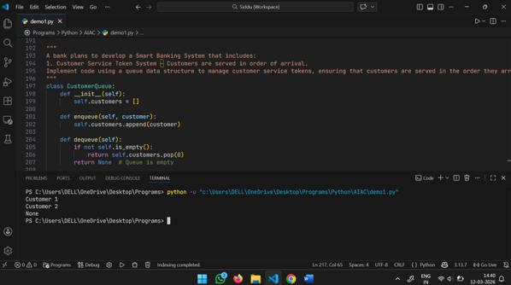
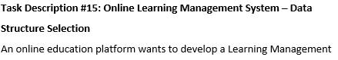
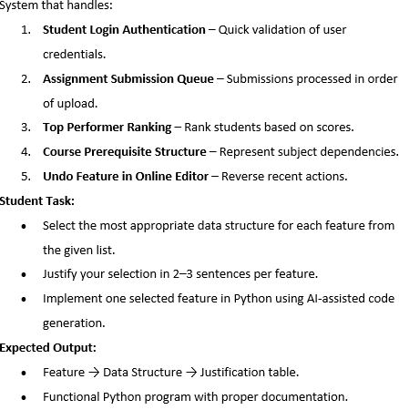

Feature | Data Structure | Justification
Student Login Authentication | Hash Table | Student login credentials can be stored using username as a key. Hash tables allow very fast lookup and validation of user information. This makes authentication quick and efficient.
Assignment Submission Queue | Queue | Assignments are processed in the order they are submitted by students. Queue follows the FIFO (First In First Out) principle. This ensures fair processing of submissions.
Top Performer Ranking | Priority Queue | Students can be ranked based on their scores. Priority Queue helps retrieve students with highest marks first. This is useful for displaying top performers.
Course Prerequisite Structure | Graph | Courses may depend on other prerequisite courses. Graph structure represents relationships between subjects. It helps track course dependencies easily.
Undo Feature in Online Editor | Stack | Stack follows the LIFO (Last In First Out) principle. The last action performed can be undone first. This makes it suitable for implementing undo functionality.
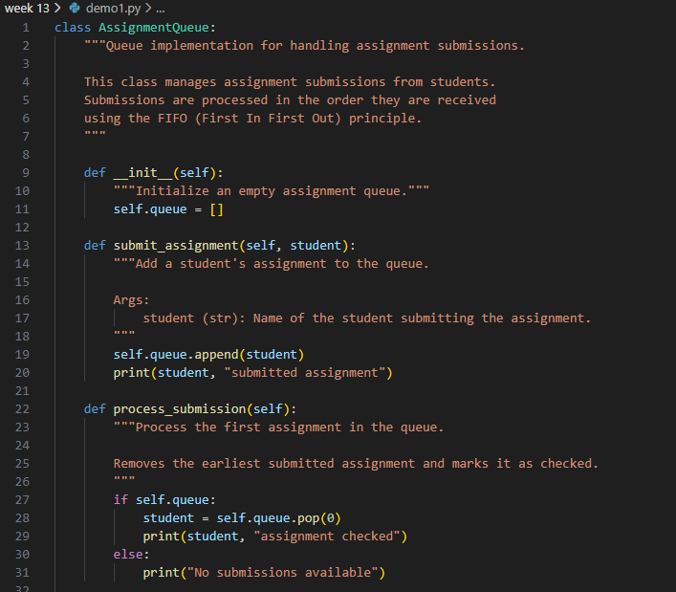

Output :
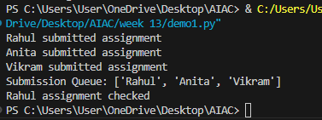

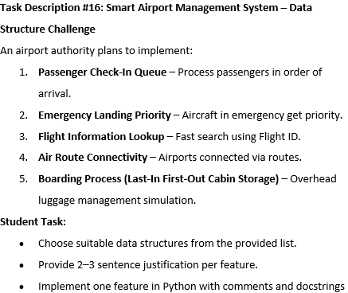

Feature | Data Structure | Justification
Passenger Check-In Queue | Queue | Passengers are processed in the order they arrive at the airport check-in counter. Queue follows the FIFO (First In First Out) principle. This ensures fair and orderly passenger processing.
Emergency Landing Priority | Priority Queue | Aircraft in emergency situations must land before normal flights. Priority Queue allows aircraft with higher priority to be processed first. This ensures safety and quick response.
Flight Information Lookup | Hash Table | Flight details can be stored using flight ID as a key. Hash tables allow very fast lookup operations. This helps airport staff quickly retrieve flight information.
Air Route Connectivity | Graph | Airports are connected through flight routes forming a network. Graph data structure represents these connections effectively. It helps in managing and analyzing flight paths.
Boarding Process (Cabin Storage Simulation) | Stack | Overhead cabin storage often follows a last-in first-out pattern. Stack allows the most recently placed luggage to be removed first. This simulates luggage handling in overhead bins.
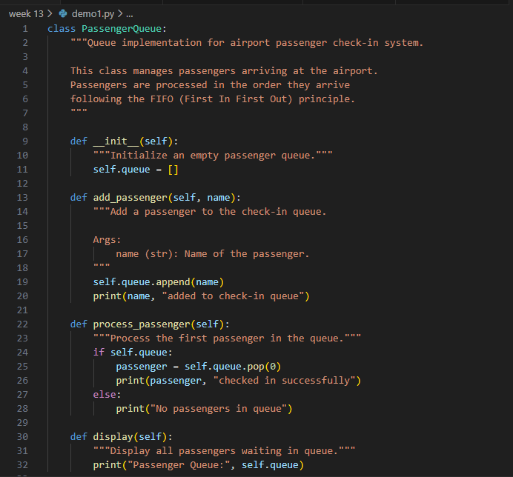
Output :
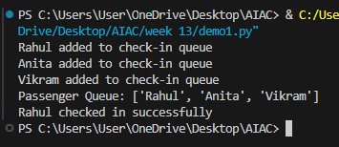
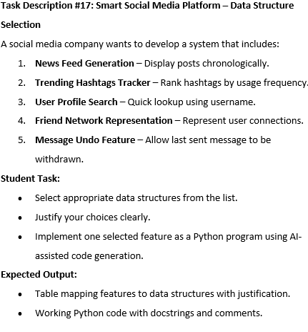

Feature | Data Structure | Justification
News Feed Generation | Linked List | Posts appear chronologically and new posts are continuously added. Linked lists allow easy insertion of new posts without shifting elements. This helps maintain the feed efficiently.
Trending Hashtags Tracker | Priority Queue | Hashtags can be ranked based on frequency of usage. Priority queue allows the most frequently used hashtags to appear first. This helps display trending topics quickly.
User Profile Search | Hash Table | User profiles can be stored using usernames as keys. Hash tables allow very fast lookup and retrieval. This helps quickly find user profiles.
Friend Network Representation | Graph | Users and their friendships form a network structure. Graph represents connections between users effectively. It helps analyze relationships and connections between people.
Message Undo Feature | Stack | Stack follows the LIFO (Last In First Out) principle. The most recent message action can be undone first. This makes it suitable for undo functionality.
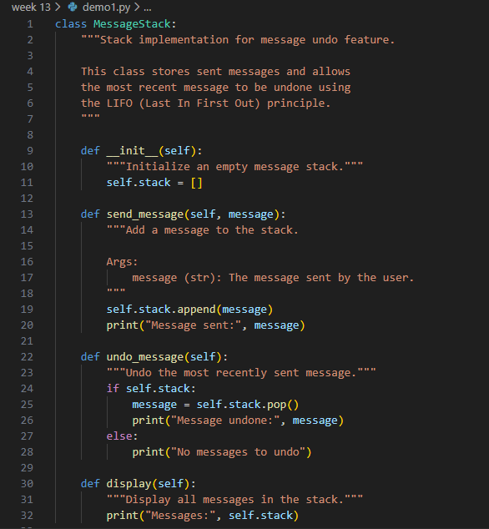
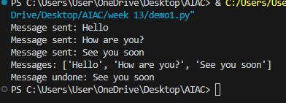
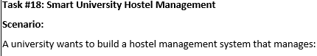
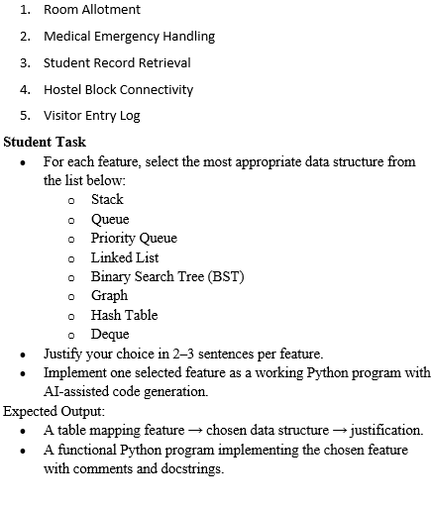

Feature | Data Structure | Justification
Room Allotment | Queue | Students are allotted hostel rooms in the order they apply. Queue follows the FIFO (First In First Out) principle. This ensures fair and organized room allocation.
Medical Emergency Handling | Priority Queue | Students with medical emergencies must receive immediate attention. Priority Queue processes cases based on urgency instead of arrival order. This ensures critical situations are handled first.
Student Record Retrieval | Hash Table | Student records can be stored using student ID as a key. Hash tables allow very fast lookup and retrieval operations. This helps administrators access records quickly.
Hostel Block Connectivity | Graph | Hostel blocks and facilities are connected like a network. Graph data structure represents these connections effectively. It helps in navigation and infrastructure planning.
Visitor Entry Log | Stack | The most recent visitor entry may need to be checked or removed first. Stack follows the LIFO (Last In First Out) principle. This makes it useful for maintaining visitor logs.

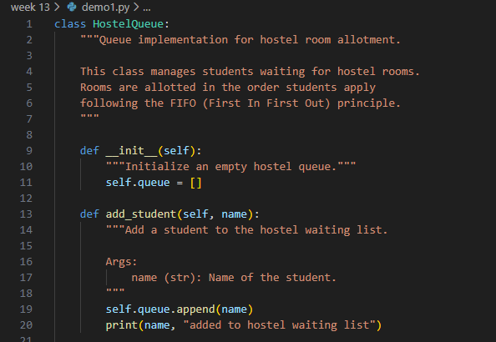

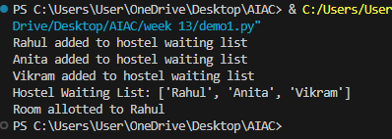
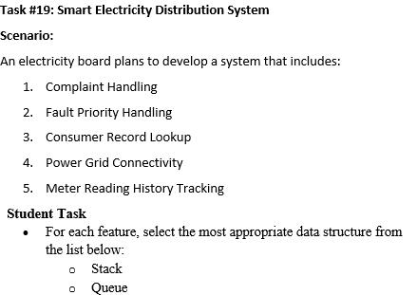
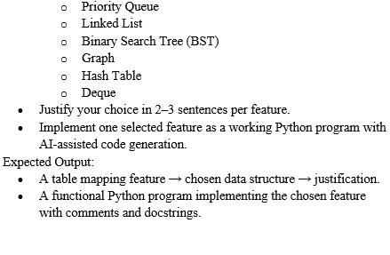

Feature | Data Structure | Justification
Complaint Handling | Queue | Consumer complaints are handled in the order they are received. Queue follows the FIFO (First In First Out) principle. This ensures fair processing of complaints.
Fault Priority Handling | Priority Queue | Some faults may be critical and require immediate attention. Priority Queue processes issues based on urgency rather than arrival order. This ensures serious problems are resolved first.
Consumer Record Lookup | Hash Table | Consumer information can be stored using consumer ID as a key. Hash tables allow very fast lookup and retrieval. This helps quickly access consumer details.
Power Grid Connectivity | Graph | Power stations and substations are connected like a network. Graph data structure represents these connections effectively. It helps analyze and manage power distribution routes.
Meter Reading History Tracking | Linked List | Meter readings are recorded regularly over time. Linked lists allow easy insertion of new readings without shifting data. This helps maintain a chronological record.

